In the solution directory ( the directory with the solution file .sln

Create a folder named Dependencies and inside Dependencies create another folder names GLFW

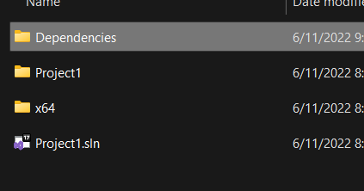

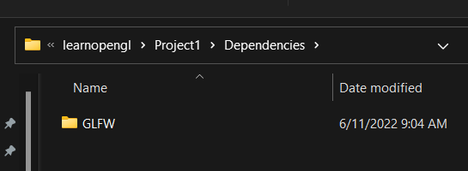

And then go to the extracted glfw folder

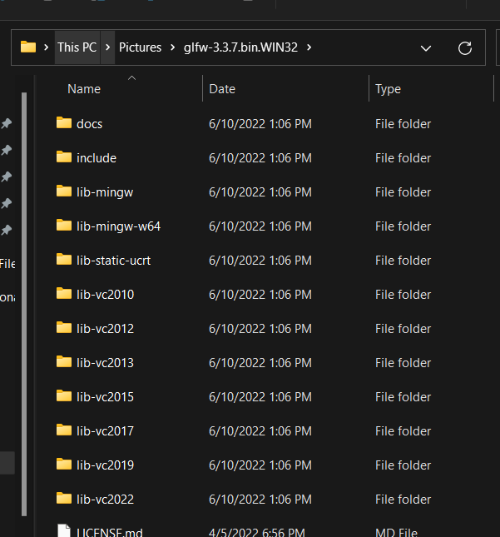

Here grab the include and lib-vc2015 folder

Copy them and paste them to the GLFW folder created inside Dependencies

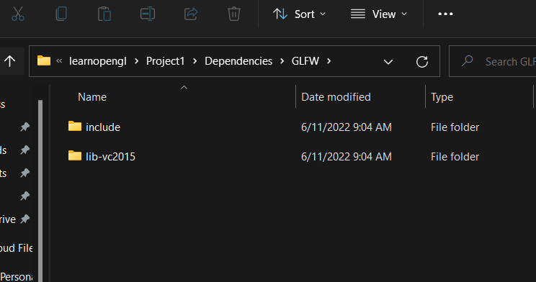

Now see how linker and other settings are adjusted for the project

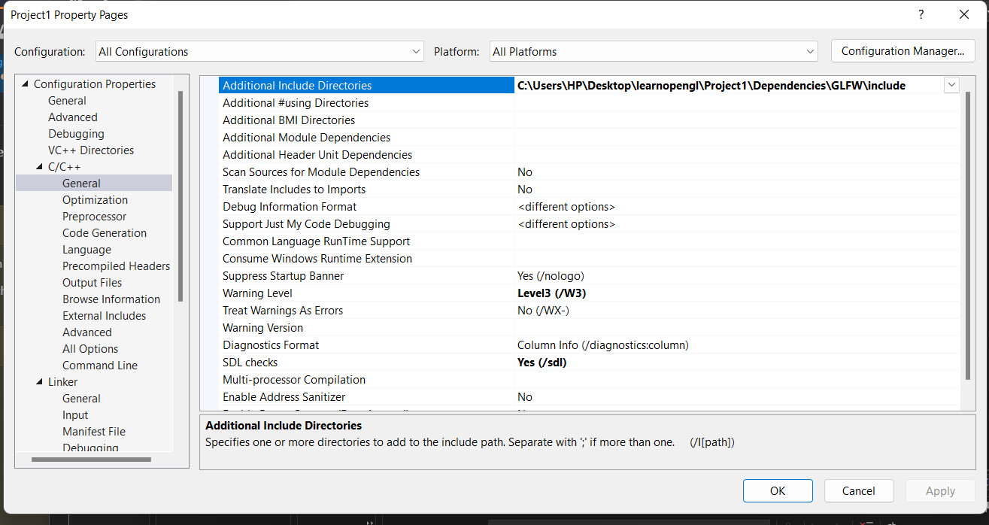

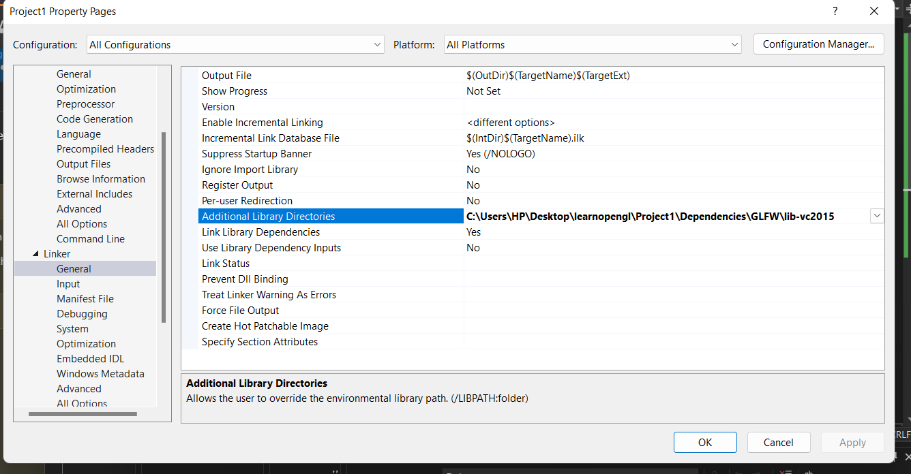

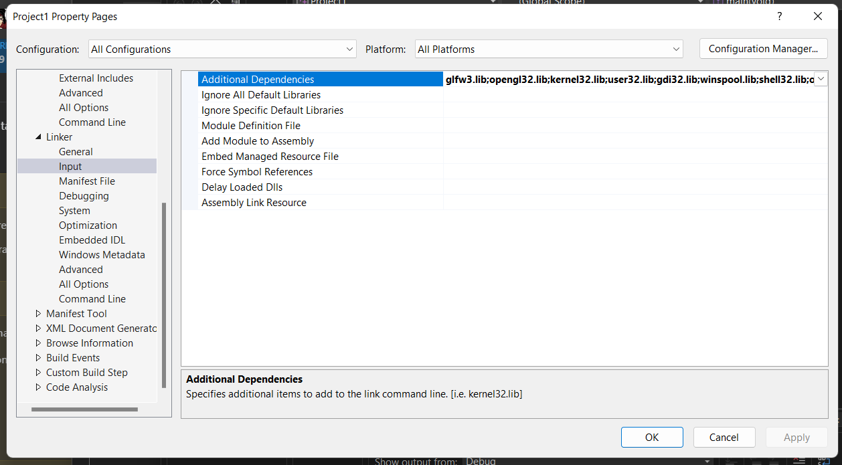

glfw3.lib;opengl32.lib;kernel32.lib;user32.lib;gdi32.lib;winspool.lib;shell32.lib;ole32.lib;oleaut32.lib;uuid.lib;comdlg32.lib;advapi32.lib;glfw3.lib

Every functions needed to work with open gl are already in graphics card and are in the graphics files in system

So there is a library that helps to get all those function called

glew

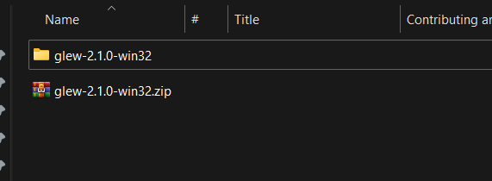

Download and extract the zip file

Now go in our project where we have already created dependencies folder

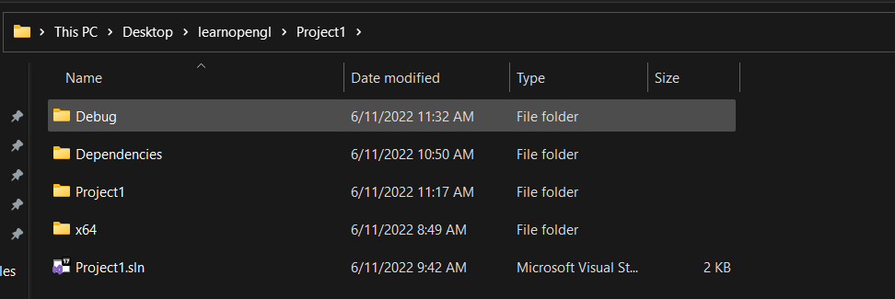

Go inside dependencies

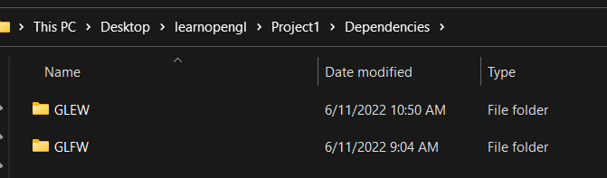

Go inside the extracted folder and copy it to dependencies folder and rename it to GLEW

Now we need to take care of few header files and linkers for GLEW also

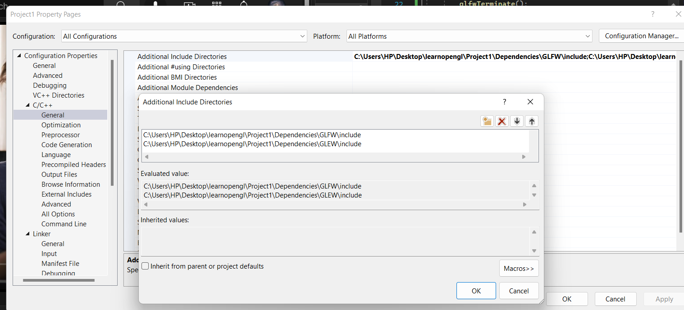

Similar to above, just add directory path for glew also

Now for linker

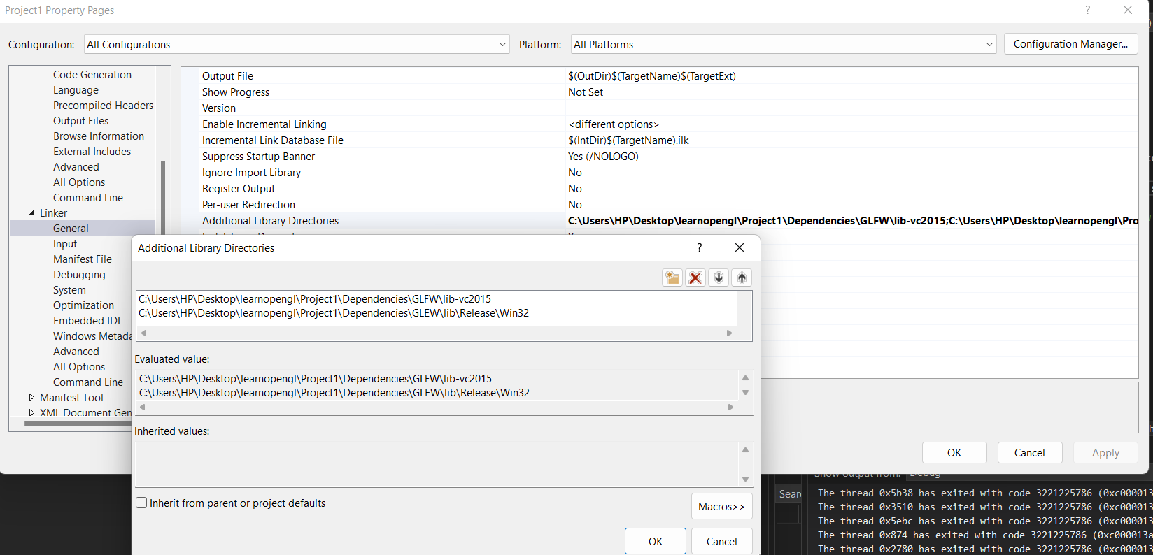

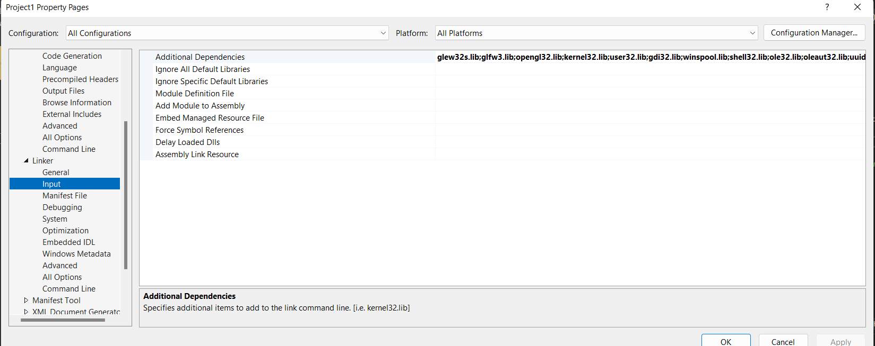

Here add just

glew32s.lib;